Name _____________________________________________________________________________
-ip word family
Directions: Choose a ship. Color it appropriately. Write the word for the picture that is on the ship.
All words will end with -ip.
- 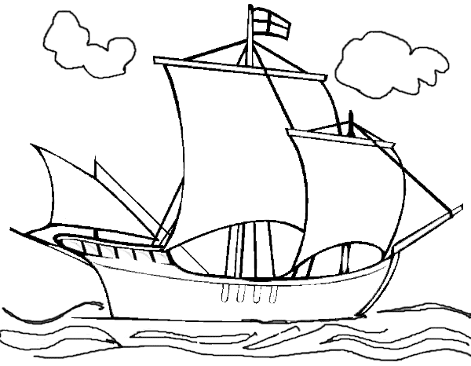 __________________________ 4. _________________________

- __________________________ 5. _________________________

- __________________________ 6. _________________________
Choose 1 –ip word and write a sentence.

__________________________________________________________________________________

__________________________________________________________________________________

